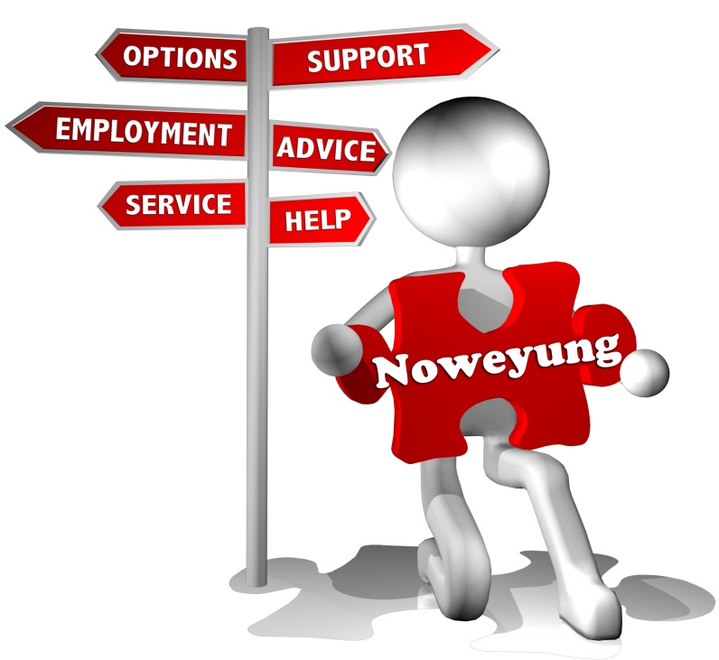
Learner Guide
TOPIC 1: AN INTRODUCTION TO DISABILITY SUPPORT WORK:
LESSON 1 & 2

Kick Start Your Career in the Disability Sector
Welcome

There are many different disabilities that impact the way people manage their daily lives and participate in the community. This means that Disability Support Workers work in many different roles and have a range of skills and attributes.

This work book covers two lessons which introduce the subject of disability work.

Lesson 1: An introduction to disability support work

What do disability support workers do?
- Employability skills: the skills we need for work
- The role of a disability support worker
- Different types of disability

Lesson 2: Disability awareness

What do disability support workers need to know about disabilities?
- What people can do and how they might feel
- Different ways to provide support
- An introduction to challenging behaviours

This workbook is a guide to classroom activities and a record of the work you have covered in this course.

Lesson 1: An introduction to disability support work
1: Employability Skills

A group of industry representatives and employers agreed that we need some general skills for the work place to help complete work-based activities effectively. They came up with a list of skills which they called employability skills.
These skills can be used in different work settings and job roles and are sometimes referred to as generic, transferrable or the soft skills of industry.
These eight skills are:
Communication, Teamwork, Problem Solving, Initiative & Enterprise, Planning & Organising, Self-management, Learning, Technology

1.1 About employability skills

- What are technical skills?

- What are soft/employability skills? Give examples.

- Why are these skills important?

- How do we get employability skills?

- Write down two employability skills that you think you have. How did you get these skills?

1.2: The Marshmallow Challenge

What skills did you use in this challenge? What did you learn about yourself?

2: Disabilities and the Role of the Support Worker

What is Disability?

The Australian Network on Disability defines disability as “any condition that restricts a person's mental, sensory or mobility functions. It may be caused by accident, trauma, genetics or disease. A disability may be temporary or permanent, total or partial, lifelong or acquired, visible or invisible” and more than 4 million Australians have a disability of some type.
https://www.and.org.au/pages/disability-statistics.html
2.1: About Disability

- What are the different types of disability as defined in the Disability Discrimination Act? Provide some examples.

- What are congenital disabilities? Give some examples.

- What are acquired disabilities? Give some examples.

- Where do people with disabilities live?

- What is the role of the disability support worker?

- What skills and characteristics do disability workers need to work in the industry?

3: Different Abilities
We know that more than 4 million Australians have some form of disability which is one in five people (The Australian Network on Disability) and that the Disability Discrimination Act has defined five categories of disabilities.

Working with a partner, choose an example of a disability from the list we discussed earlier.

Research and discuss the following questions.
Is this disability:
- An acquired or congenital disability?
- How does it affect the person?
- What type of support would someone with this type of disability need?

You will have approximately 30 minutes. Prepare notes and present your findings to the class.

Lesson 2: Disability awareness

Knowing how disabilities can affect people helps us to develop empathy or understand why someone is behaving in a certain way or why they struggle with certain tasks. The following activities are designed to develop an understanding of some of the issues people face and to think about ways a disability worker might provide support.

Activity: Autism Awareness

Instructions:

We will divide into groups of 5 and each will each have a job to do.

One student in each group will play the part of someone with autism. The other 4 people each have different jobs.

The roles are:

Person 1: You will play the part of a person with autism. Your job is to try and listen to what Person 5 is reading to you so you can take a test on the material. Try to ignore everyone else.

Person 2: Stand behind the student playing the part of someone with autism. Rub the edge of an index card (or piece of cardboard) against the back of their neck. You do not need to rub hard but keep doing it over and over.

Person 3: Grab a book (any book will do), lean close to Person #1 and read in a loud voice the entire time.

Person 4: Pat Person 1 on the head and shoulder the entire time.

Person 5: Using a normal voice, read a paragraph to Person 1 then ask them questions about what you read. Do NOT try to drown out the other noises.

When you have all had a turn at being Person 1 we will discuss these questions together.

Questions

- How did it feel to be have so much commotion going on?
- Did it make them want to scream or get away?
- Were they able to concentrate on the paragraph being read?
- What might have helped?

Source: Disability Awareness Activity Packet Activities and Resources for teaching Students About Disabilities by Bev Adcock and Michael Remus
Autism: An Overview

Autism is a congenital, neurodevelopmental condition which affects people in different ways.

The three main areas where people experience difficulty are:

Social interaction which may include:
- Limited use and understanding of non-verbal communication such as eye gaze, facial expression and gesture
- Difficulties forming and sustaining friendships
- Lack of seeking to share enjoyment, interest and activities with other people
- Difficulties with social and emotional responsiveness

Social communication which may include:
- Difficulties initialising and sustaining conversations
- Stereotyped and repetitive use of language such as repeating phrases from television
- Talking continuously about one topic
- Not understanding humour, be literal in their interpretation of language or having difficulty taking turns in a conversation

Restricted and repetitive interests, activities and behaviours which may include:
- Unusually intense or focused interests
- Stereotyped and repetitive body movements such as rocking, pacing or arm flapping
- Adherence to routines
- Unusual sensory interests
- Sensory sensitivities to everyday sounds, smells, light, touch and taste
- Intellectual impairment or learning difficulties

The common characteristic of people who have autism is that each is unique.

Source: http://www.amaze.org.au/uploads/2016/04/Amaze-Info-Booklet-April-2016-web.pdf

Notes

2.1: Assistive Technology

Adaptive technologies can be used to support people with a range of needs. For example, it may be necessary to adapt the physical environment to assist people to access the community, employment or training.

2.1: Research Assistive technology

- Provide a definition for the term, assistive technology, giving examples.

- Investigate three items of assistive technology that might be used to assist someone with a disability.
List the technology/equipment, describe what it does, how it assists, who would use it (the client or the carer) and what the benefits of using this technology/equipment are.

2.2: Accessibility Options Computers and Mobile Devices

We use computers to complete daily living activities such as banking, My Gov, booking flights and accommodation and for entertainment. This can be difficult for some people for various reasons.

- What existing accessibility functions are available to assist people with disabilities?

- Which computer options or apps could you use to assist with the problems you experienced?

- What apps are available to download to a mobile device?

3: Challenging Behaviours
Disability support workers are exposed to a range of challenging behaviours in the course of their daily work. These behaviours can be distressing and stressful for the person displaying the behaviour and for those around.

3.1 Understanding challenging behaviours

Watch the video: Understanding Challenging Behaviours
Video: Understanding challenging behaviours
https://youtu.be/tQTx26ELkSs
Time frame: 3 minutes

- What are the main takeaways from this video?

3.2 Understanding Challenging Behaviours Part 2

- What are challenging behaviours? Give some examples.

- Why do challenging behaviours happen?

- What are some strategies we can use to support a person who has challenging behaviours?

