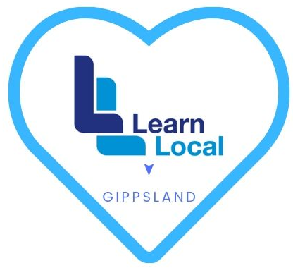

LOVE YOUR LEARN LOCAL
CHAMPION TOOLKIT

January 2020

Welcome Letter

Dear xxx

Welcome on to the Love your Learn Local project, it’s great to have you on board and we look forward to working with you as we continue to develop the profile of Learn Local in the Gippsland region

To support your appointment as a Love your Learn Local Champion we have produced the following resources to support you as we seek to raise the profile of Learn Local in Gippsland.

The project has developed a library of valuable reference material that will support you in marketing the Learn Local brand and its products, and also help you educate your teams on the key elements of the Learn Local offering and how the brand can be communicated and presented to our key audiences including Learners, Community Groups, Job Service providers and the broader community. These resources will be available through the Gippsland Learn Local website https://www.gippslandlearnlocal.community/

In this edition of the tool kit, we provide you with
- The objectives of the Love your Learn Local project
- Background on the Adult Learning sector, clarity around what pre-accredited training is and how Learn Local meets the needs of its key audiences
- A view on Marketing Learn Local in your region including information on how to use Gippsland Learn Local materials to support your own local marketing activities

Thank you for your ongoing support of Learn Locals in Gippsland communities and please feel free to contact the Love your Learn Local team as needed.

Regards

Love your Learn Local team

PART 1 :

THE LOVE YOUR

LEARN LOCAL

PROJECT

About the Love your Learn Local Project

Background
In early 2019 Learn Local conducted a study to identify opportunities to increase community participation in Learn Local pre-accredited courses and in doing so identified:
- An opportunity to give deeper meaning, understanding and comprehension of what Learn Local pre-accredited training is and the positive impact LL courses can provide for local communities.

- An opportunity to provide valuable information to community groups and service providers about the Learn Local brand.

- An opportunity to emphasise how the quality framework used to develop Learn Local programs makes them much more than short courses - they are reflective of the needs of community, industry and business across Gippsland, particularly in relation to Digital Literacy, Vocational Skills & Training and Language & Literacy

Purpose
With an understanding of how time pressures and demands experienced across the network of not-for-profit Learn Local providers can limit the ability to effectively market courses, Buchan Neighbourhood House submitted a proposal for CAIF 11 funding support that would help providers through the provision of a dedicated resource responsible for working with each of the providers as they promote their courses at a local level
A key component of the Love your Learn Local project is the recruitment of volunteer Learn Local Champions with whom the GLL team would support to understand each of their unique challenges and provide them with ideas, support and resources to help enhance the awareness of the Learn Local brand and courses in order to drive enrolments

PART 2 :

ABOUT LEARN LOCAL

The Adult & Community Education sector

Adult education provides adults with learning opportunities beyond traditional schooling.

It provides new forms of knowledge, skills, attitudes, and values that help adults to further enrich their lives, provide personal fulfillment and remain relevant through continued development of their skills

As part of the Victorian Governments 2006 Education & Training Reform Act, The Adult, Community & Further Education (ACFE) Board was appointed as the statutory authority responsible for providing funding to community-based organisations including registered Learn Local providers who deliver education & training programs that support and meet the education & development needs of Victorians over school-leaving age, with a focus on people who have had limited access to education

Learn Local providers are recognised as having a connection and understanding of their local communities and because of this are best equipped to deliver flexible programs that genuinely meet learners needs at a local level whilst effectively supporting them as they return to study, improve their literacy and numeracy skills, gain a qualification, and broaden their employment options

What is Pre-accredited training?

Pre-accredited training is the formal term used for programs delivered by Learn Local - it describes the delivery of short modular courses (generally 6 - 8 continuous weeks) designed for learners who have not achieved Year 12 or an equivalent and helps them gain the necessary confidence and skills to build rewarding and effective pathways to further education and training or bring them a step closer to securing employment.
Pre-accredited training helps those members of the community who through life circumstances have disconnected with traditional education and are seeking to enrich and move forward with their lives having recognised the value of education and the important role it plays in enriching their lives, future prospects and participation in their community

Participation in Learn Local courses is recognised with a Certificate of Participation and outlines a suite of skills that learners acquire from the course. The certificate helps to demonstrate the commitment & growing skill set of learners as they progress toward more formal education or seeking employment
The importance of the contribution that pre-accredited training makes to the community has been acknowledged by Job Actives who now include Learn Local courses in their suite of education options

What type of programs do Learn Local provide?
Learn Local is the brand that the ACFE board use to identify adult community education/courses that are endorsed and subsidised by the ACFE board and can only be delivered by not-for-profit organisations such as Neighbourhood Houses, Community Houses and Registered Training Organisations.
Learn Local courses are designed by Learn Locals using a learner-centred approach focused on one of three learning categories identified by the ACFE board as important to the future growth & success of individuals and communities
Adult Literacy & Numeracy  Training that helps to improve communication and one’s ability to interpret & effectively communicate mathematical information & ideas | Digital Literacy  Training that improves skills you need to live, learn, and work in a society where communication and access to information is increasingly through digital technologies like internet platforms, social media, and mobile device transferable skills needed by an individual to make them ‘employable’ |  | Vocational training  Training that emphasizes skills and knowledge required for a particular job function (such as typing or data entry) or a trade (such as carpentry or welding)
“Ready to Work”  Orbost Education Centre  www.orbostedcentre.org.au | “Digital Literacy for the Workplace”  Warragul Community House  www.warragulcommunityhouse.org.au |  | “Kick Start your Career in the Health Sector”  Noweyung Learn Local  www.noweyung.org.au
Build Employability skills  Communication Skills  Teamwork Skills  Problem Solving skills  Initiative & enterprise skills  Planning & Organisational skills  Self-management skills  Learning skills  Technology Skills |  | Create pathways to  further qualification  and/or employment

Refer to the Learn Local website for more information and resources:
https://learnlocal.org.au/

How are Learn Local programs developed?
Across Gippsland, Learn Local organisations have a proven track record for delivering quality assured, relevant and highly effective, pre-accredited Learn Local courses that close learning and training gaps that exist in their local communities and help individuals build pathways to study or work locally.
A key instrument driving the success of the courses stems from the use of the ACFE Board’s Pre-Accredited Quality Framework. This framework underpins the courses developed by Learn Local providers and helps direct their programs to achieving not only funding but most importantly ACFE quality endorsement.

Key elements of the Pre-accredited Quality Framework include:
Course Design | A learner-centred approach | Quality Teaching
- Input/feedback from learners, community groups, industry and Learn Local providers and staff  - Clear understanding of the pathways associated with employment and further education  - Continuous reflection on teaching learning practice to inform future development of courses. | - Reflects the personal, community and employment needs of their community  - Helps to improve skills, behaviours and confidence during and beyond the course itself  - Activities focus on development of employability skills | - Qualified teachers with the knowledge, skills & expertise to effectively engage learners  - Activities focus on development of employability skills

Who delivers the courses?
Learn Local tutors are recruited from within local communities, they have the relevant skills, knowledge and sector experience. Learn Local tutors have relevant and real life experience, they are well connected with established sector networks that contribute to the quality and depth of the courses they facilitate.
The Quality Indicators for quality Learn Local tutors are:
- The tutor has the knowledge and skills to engage learners.
- The tutor has the relevant content expertise.
- The tutor is engaged in on-going professional development to support quality pre-accredited delivery.

For more information re Learn Local tutors/facilitators refer to:

https://www.gippslandlearnlocal.community/teach

How successful are Learn Local courses?

Each year, over 28,000 Victorians choose to participate in Learn Local training. Students comes from a wide range of backgrounds and choose to study with Learn Local not only because it is close to home, but also because they offer a friendly environment with teachers who have a genuine commitment and passion in helping participants succeed.

.
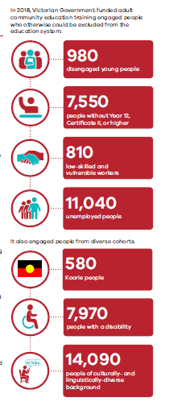
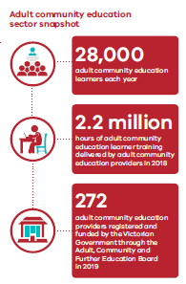
How have Learn Local courses changed people’s lives?
It is the learner stories that provide a human portrayal of how Learn Local has impacted the lives of learners and provided them with valuable skills to move forward with their lives
Over a number of years Learn Local has collected numerous case studies from learners and key industry sectors that prove the unique benefits Learn Local courses deliver.
Additional stories and resources visit the Learn Local and Gippsland Learn Local websites: https://www.gippslandlearnlocal.community/
https://learnlocal.org.au/stories-from-learners/
BUILDING CONFIDENCE
 | 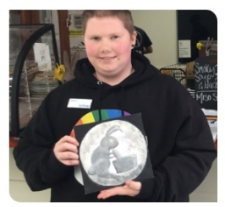 | 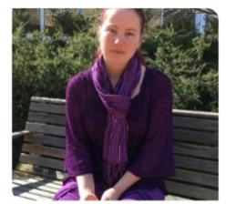
“I just wanted to help my son with his homework and not feel like I can’t help him.” | Now I know what I want to do | Samantha wants everyone to know that having a disability doesn’t need to hold you back from further study or finding a job.
https://learnlocal.org.au/story/i-fit-in-here/ | https://learnlocal.org.au/story/i-wasnt-super-confident/ | https://youtu.be/9tPVUMzz4tA?t=2
CHANGING CAREER
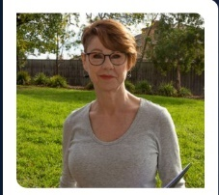 | 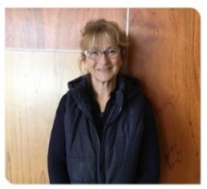
“I want to get the most out of what I am learning.” | “I want to keep working.” | “From sewing to surfing”
https://learnlocal.org.au/story/time-for-a-career-shift/ | https://youtu.be/QBrDb2ZGupM | https://learnlocal.org.au/story/from-seamstress-to-computer-whiz/
GETTING INDUSTRY SPECIFIC TRAINING
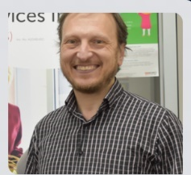 |  | 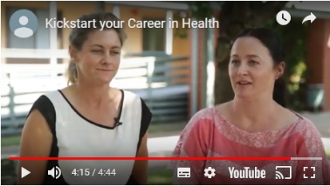
“I wanted to know more.” | Kickstart a career in Call Centre operations | Kickstart your Career in the Health Sector
https://learnlocal.org.au/story/an-opportunity-for-a-new-career/ | https://youtu.be/WMn-JuFJVx4 | https://youtu.be/9ZqQ7OXSQeg
BUILDING NEW SKILLS
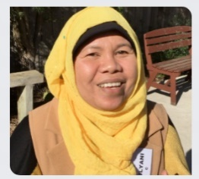 | 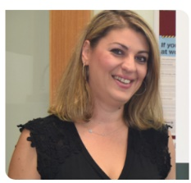 | 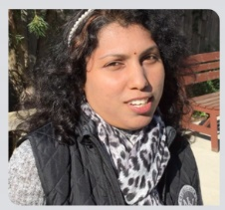
Building new skills | Something for yourself | Learning with friends
https://youtu.be/ujwJbeCRoT0 | https://youtu.be/R1gPJUi3BB0 | https://youtu.be/5v-XUPDYaBg

How to communicate the Learn Local offering

Wondering about how best to present Learn Local to different audiences?
In November 2019, Learn Local released its updated brand guidelines and provided valuable direction on the best way to communicate Learn Local to key audiences.
You can find out more and for a full range a resources go to https://www.education.vic.gov.au/training/providers/learnlocal/Pages/brandtoolkit.aspx and click on the Learn Local Brandmark Guidelines.

PART 2 :

LEARN LOCAL MARKETING PLAN

Building your marketing strategy

An example only

BUSINESS OBJECTIVE

Increase learner participation in “your LL” Learn Local courses

Maximise enrolments for 2020

Achieve capacity in class numbers for “your LL” Learn Local courses

MARKETING OBJECTIVES

Maximise awareness and consideration of Learn Local courses across “your community”

Drive enquiry to “your LL” Learn Local

Maximise referrals from community organisations and job service providers

UNDERSTANDING THE LEARNER JOURNEY

In order to understand how best to reach potential learners – it is valuable to understand the steps learners take as they go about identifying an education provider - from this you can then determine the impact of marketing Learn Local in your community.

.
 | Step 1 | Step 2 | Step 3 | Step 4 | Step 5 | Step 6 | Step 7 | Step 8
Learner Journey | Identify need for education | Search & Research options | Collect information | Form opinions & perceptions | Determine which brand /course meets their needs | Enquire | Enrollment | Participate
Role of Marketing | Drive awareness |  | Drive consideration |  |  | Drive action |  | Encourage advocacy
What messages are most effective | Brand positioning including Why, What How & benefits deliverd by Learn Local with the capacity to enquire |  | Learner stories, expert opinions, referrals from key influencers (industry, business, education) with the motivation to enquire |  |  | Course details including the where & when with a capacity to book |  | User generated content
What channels are most effective | PAID & OWNED |  | OWNED & EARNED |  |  | OWNED |  | OWNED
 | External advertising  Newspapers  Website |  | Website, paid Social Media,  Letterbox drops, brochures, video’s, PR coverage |  |  | Website, social channels, E-Newsletters |  | Social Media  reviews
Who | Learn Local Brand |  |  |  | Learn Local Providers

DEFINING EACH PARTIES ROLE

Learn Local brand | Learn Local provider
Drive top of mind awareness of the Learn Local brand and how the product delivers  Provide proof of pre-accredited training and the difference courses can make | Promote, deliver & market the full suite of courses/services they provide of which LL represent one-third.  Drive referrals and enquiry

Driving Awareness ideas – Learn Local brand and providers

Leverage events/seasons with a relevant Facebook Post to key partners and potential stakeholders

Idea: Using Canva (free) design an Easter card or emphasis the event message. Despatch the card via email and/or post it on Facebook 10 days before. Support with a link to a branded landing page* to highlight the release of each term courses and the option to register their interest via a contact form.

Outdoor Billboards/Posters

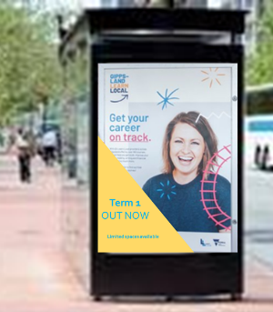
Outdoor signage (particularly large billboards, transit shelters) have the capacity to provide not only 24x7 exposure for Learn Local but also effectively reach an average of 40-50% of demographics served by Learn Local courses. This becomes even more important when trying to reach the under 25 year old audience whose one of the most elusive audiences to reach with traditional channels. Collaborate with established partners to present a common focus and reach a broader target market.

Newspapers

Local Newspapers have been identified as a key tool for LLO’s however they do skew to a specific demographic.

Collaborate with established partners to present a common focus and reach a broader target market.

Email Signatures

With numerous emails despatched daily use the Email signature real-estate to promote Term activities and/or branded messages

Provide all your staff with a pre-made Learn Local signature and/or provide them with instructions on how to build one and use it to drive enquiry to your course guide/bookings

Resource link: https://www.youtube.com/watch?v=C2n0ywfAtDE

Driving Consideration ideas – Learn Local brand and providers

A key component of marketing LL courses is deepening the relationship key audiences have with the brand. When reaching out to the Learn Local target groups its not enough to just talk about what you’ve built you need to tell the story of what we can achieve ….

Case Study Flyers

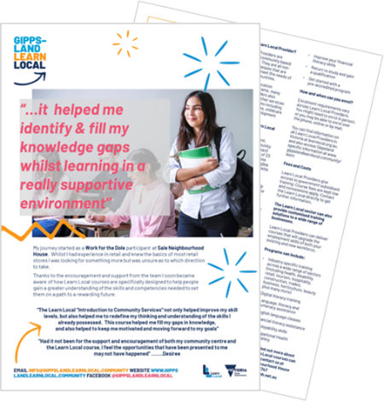

Adding a human face to your LL printed materials that outlines their experiences and the core benefits experienced in their own langugage will provide a powerful extension to your branded (generic & course) flyers. Use ‘free stock images’ (in order to manage privacy issues) and overlay them with genuine comments from learners. The power of the comment combined with the image, is a strong way to present the case studies, particular as a stand alone flyer.

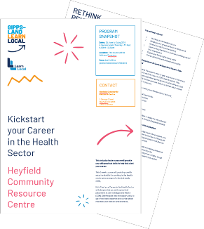
Ideally a minimum of four case studies would be developed to represent each of your key cohorts.

The format of these flyers would present the case study on the lead page, and then back page can use the the generic flyer copy to outline the why, what & how of Learn Local education

Radio Interviews

Maximise the use of local radio connections and schedule interviews with key organisations and champions at the key promotion dates in your annual calendar.

Suggested outline would be:

Intro: Highlighting key news/points highlighted in recent Ministerial or State Government statements eg: the recent recognition of pre-accredited training as the third key element of post school education

Body: Background on Learn Local students which outlines their journey with Learn Local courses and what they got from the experience and where they hope their future will lead

End: Discuss how many Gippslanders have enjoyed success with Learn local courses (provide some stats) and seek an opportunity to mention some of the courses on offer in the relevant Term and where to find out more

Once aired, use an air-check of the interview to post on your Facebook and/or the GLL website. Also seek to provide Gippsland FM and other radio networks with a regular Term FB post for them to post to their audience

Digital Approach

Digital plays a pivotal role in marketing brands/products/services. Not only do consumers expect to be able to find what they need when researching brands/industries but they have also become used to being guided to relevant destinations when being exposed to marketing messages

At the same time it is essential to keep in mind that many in the Learn Local target group have limited or no access to technology

Refer to the “How to guide on social media” on the Gippsland Learn Local website

https://www.gippslandlearnlocal.community/spalg-toolkit

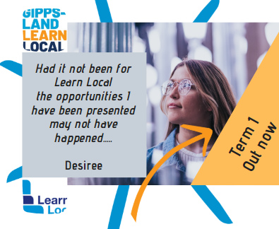
Facebook Posts

Facebook posts delivered by LLs generally focus on the Where and

When of courses, without any further support by way of a destination to find out more/enquire.

Consider creating posts that deliver a ‘brand consideration’ message focused on driving the benefits experienced by previous learners. Place

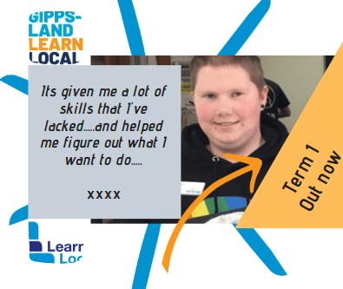
these in the weeks leading up to and at the start of eachTerm with an ‘Out Now’ / ‘Find out More’ call to action , to add further depth to the LLs activities.

Create a social media calendar for the Learn Local that includes specific dates, events and community relevant celebrations that can be linked to the brand.

Eg. Harmony Day, Cultural Diversity Week, Victorian Youth Week

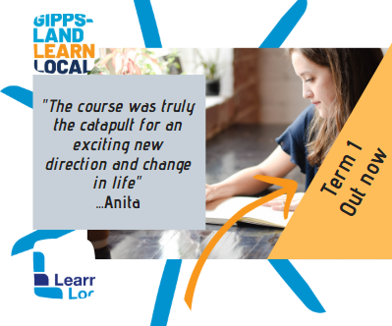
Follow the GLL FB page with the aim of reaching key partners such as Community Groups, Job Service providers, Council, Libraries, etc. and despatch for consideration for them to include in their own feeds.

PART 3:

USING LEARN LOCAL

MARKETING MATERIALS

ASSETS
As part of designing the 2019 Gippsland Learn Local, a suite of brand assets has been developed
These assets are available at https://www.gippslandlearnlocal.community/ and can be used when formulating Learn Local specific materials

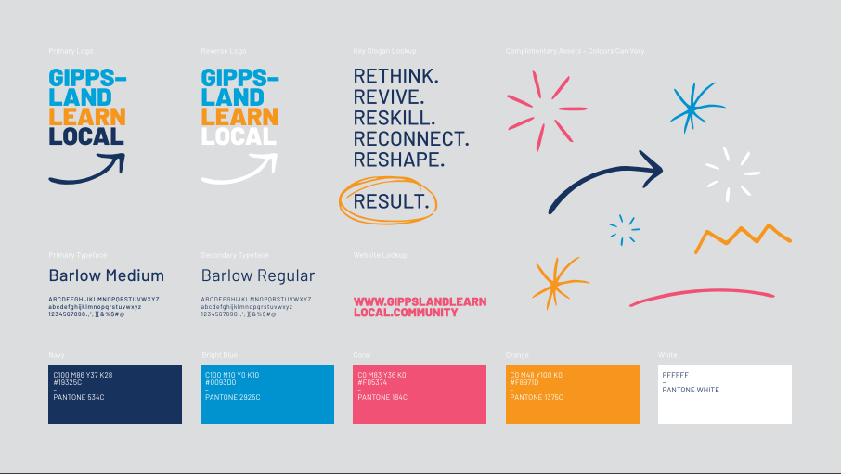

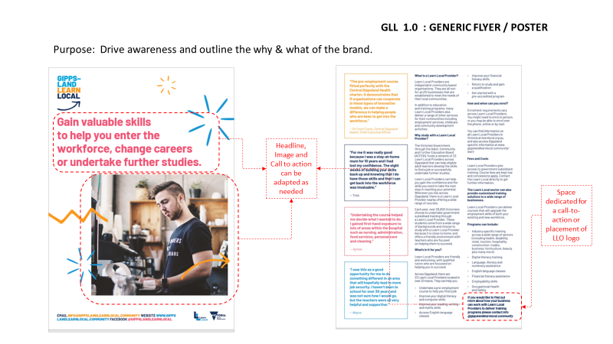
Source: SPALG project and the Warragul Community House.

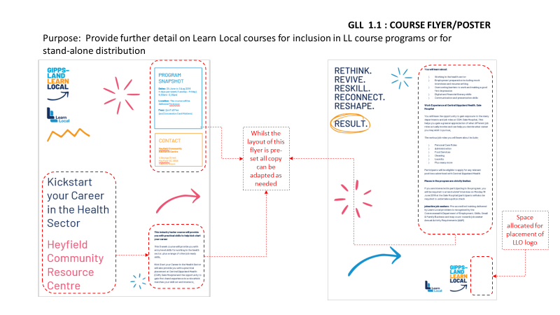
Source: SPALG project and the Warragul Community House.
