Kick Start Your Career in the Health Sector

Prepared by the teachers in the Noweyung Ltd delivery of the Health course at the Bairnsdale Regional Health Service (BRHS).
Facilitation Guide

COURSE DESCRIPTION
This is a vocational taster course focussing on unemployed and underemployed learners who want to gain employment in the health sector. This course will give participants a good insight into the skills and attributes required to work in a range of positions in support services such as food services, cleaning and portering. They will also gain knowledge of qualifications required to obtain specialist work in the health sector such as an Allied Health Assistant or Personal Care Attendant.

Participants will learn about employability skills; focusing on identifying skills they have, skills they need to develop and how important these skills are in all workplaces. On completion of the course, it is expected that the participants will be prepared to apply for any relevant positions in support services in the health industry.

PARTNERING WITH A HEALTH SERVICE
This course cannot be delivered without the support of a local health service. Our partners Central Gippsland Health, and the Bairnsdale Regional Health Service have been very generous with their time and expertise. They provide invaluable input into the pre course interview process and the work related skills component of the course which prepares learners to enter their workplace for observational work experience. Liaison with a key staff member is essential to the success of this component and the course.

THE FACILITATOR

Working in close consultation with designated hospital staff, the facilitator will need sound knowledge and well-developed strategies to provide meaningful and engaging learning experiences for adult learners.

You will need:
- Experience working with a diverse range of adult learners
- Sound knowledge of the eight employability skills addressed in the Pre-Accredited Quality Framework
- Sound knowledge and skills in literacy and communication teaching strategies to engage with learners and to teach Literacy for Work
- Knowledge and skills in digital literacy including a range of productivity tools such as MS Word, Excel and Power Point and alternatives such as Google Docs and internet and email to teach Digital Literacy for Work
- Knowledge and skills in budgeting, taxation, superannuation, debt management and insurance to teach Financial Literacy

LEARNER COHORT

This course targets learners who are keen to develop skills for employment and find out more about the health sector before they commit to training or employment and who fit the pre-accredited learner cohort including those who have not accessed education, have experienced barriers to education, CALD learners and those with limited access to educational experiences.

SUPPORTING LEARNERS

The activities in this course are designed by applying principles of inclusivity and considering adult learning principles. They are flexible and can be presented to learners using various methods and formats. For example, most activities can be completed individually, as pairs, in small groups or as a whole class.

It is suggested that learners undertake Language, Literacy and Numeracy and Digital Literacy skills assessment prior to commencing the course to identify gaps and areas were support is required.

Learners may not disclose a disability. If they do, consultation is required to ensure individual needs are met. See Disability Standards for Education 2005

LANGUAGE LITERACY AND NUMERACY
This course has been designed to align with units of competency from the Foundation Skills training package at ACSF Level 3 and Certificate III in Individual Support.

Level 3 is regarded as the “minimum required for individuals to meet the complex demands of everyday life and work in the emerging knowledge-based economy”. (See http://www.bksb.com.au/australian-core-skills-framework/).

USING TECHNOLOGY

There is a strong emphasis on using technology in the learning activities in this course. The objective of technology-based learning activities is to build digital literacy skills relevant to the workplace and to provide accessibility options to those learners who require support with text and written work.

You will need:
- Presentation equipment such as smart screen TV or data show to demonstrate apps, built in accessibility options and to present videos and slide shows
- Internet access for research activities and online videos
- Computer lab or laptops
- Access to word processing, spreadsheets and presentation software
- Mobile devices (tablets and phones, learners may use own devices)

WORK EXPERIENCE

Twelve hours of course time is allocated to work experience. This is an essential component of the course providing learners with valuable insights into the health sector, their attitudes to work and the skills required to work effectively. Learning activities are designed to prepare learners for work experience with 20 hours allocated to industry specific skills provided by hospital representatives.

Where possible, adult learners prefer hands on experience, although pre-accredited work experience guidelines recommend observational work experience only. It is important to debrief learners after their work experience and reflective questions are included in a Work Placement Logbook to be completed after work experience.

Pre-accredited work experience is guided by the Pre-Accredited Work Experience Model published by the ACFE Board. See the Pre-accredited Work Experience Guidelines for Learn Local Providers which provide the standards for observational work experience for pre-accredited learners including acceptable work experience formats.
http://www.education.vic.gov.au/training/providers/learnlocal/Pages/Pre-accredited-Work-Experience.aspx

POLICE CHECKS
Current police checks are essential to work in the health sector and learners will require a Police Check prior to commencing work placements. This should be addressed on the first day of the course to ensure time for checks to be completed and to avoid learners being excluded from work experience. Job Active Services will assist participants with this process.

WORKPLACEMENT AGREEMENTS
PARTNERSHIP AGREEMENT

ACFE requires a partnership agreement between the industry provider and Learn Local Provider. See Pre-accredited Work Experience Guidelines for Learn Local Providers. An agreement template can be downloaded from http://www.education.vic.gov.au/training/providers/learnlocal/Pages/Pre-accredited-Work-Experience.aspx

PARTICIPANT’S AGREEMENT
Learners may also be required to sign a Work Experience Agreement by the work experience host.

COURSE STRUCTURE

The lessons in this course have been developed for delivery over a five-hour day. They are generally packaged into two hour blocks to provide flexibility in delivery and to accommodate breaks. See Appendix 1: Proposed Delivery Schedule as an example of how the course might be delivered.

This is a 120 hours course which includes 12 hours work experience. It is presented in 4 core topic areas that are highly contextualised for the industry and reflect the skills and knowledge required to prepare learners for work experience and potentially work in the health sector.

THEY ARE:
Topic 1: Industry Specific Skills | 20 hours
Topic 2: Literacy for Work | 30 hours
Topic 3: Digital Literacy for Work | 20 hours
Topic 4: Financial Literacy | 20 hours

ALSO INCLUDED:

Site visits/work placements | 12 hours
Pathways planning and next steps | 10 hours
Smart Study Skills | 5 hours
Acknowledging learner’s achievements/celebration and presentation | 3 hours
GROUP PROJECT

The learners are encouraged to undertake a group project with time allocated during Digital Literacy for Work and Literacy for Work to plan and prepare the presentation. The presentation will reflect their experiences throughout the course and will be delivered on the final day to an audience of invited guests. The focus of this task is to develop employability skills; in particular teamwork and communication skills and to increase learner confidence.

EMPLOYABILITY SKILLS
Employability skills are embedded in this course.

Teachers should be guided by learner’s responses recorded in PQF Learner Plan Part 1. Learning activities can be adapted to reflect the needs of the learner group.

See Teacher Guide and Pre-accredited Quality Framework Teaching Guide P.16 – 19 for more information on employability skills in pre-accredited training.
Download Pre-accredited Quality Framework Kit here: https://www.education.vic.gov.au/training/providers/learnlocal/Pages/pqf.aspx

TOPICS
TOPIC 1: INDUSTRY SPECIFIC SKILLS.

Industry Specific Skills includes an introductory tour of the hospital to familiarise learners with the health environment, an introduction to Work, Health and Safety with an emphasis on manual handling and hand hygiene in preparation for work experience and self-care which covers conflict resolution and stress management.

These sessions are provided by hospital staff responsible for these areas. This topic also includes presentations from managers of different work areas in the health service regarding the work conditions, skills and attributes required to work in support services. As examples, food services, aged care, allied health services, environmental services and sterilisation.

This is a unique opportunity for learners to interact with managers and staff who work in the different areas of the support services and to seek information about the skills and qualifications they need to work in these areas.

TOPIC 2: LITERACY FOR WORK

These lessons focus on communication skills that are important in the workplace including speaking and listening and reading and writing skills. Topics covered are active listening, effective feedback, giving and receiving instructions and questioning techniques in the context of workplace interactions. Reading skills focus on understanding workplace documents like Social Media, Privacy and Confidentiality and Dress/Uniform policy and procedures and job descriptions. Writing skills focus on skills to write a resume, cover letter and address Key Selection Criteria. Learners undertake activities to prepare them for job interviews including a mock interview conducted by representatives from the hospital.

TOPIC 3: DIGITAL LITERACY FOR WORK

Digital Literacy for Work covers basic computer skills including an introduction to productivity tools. Topics covered are computer basics, Internet and email, staying safe online, word processing and presentation software.

TOPIC 4: FINANCIAL LITERACY

Financial literacy is based on ASICs Be Money Smart. This course is comprised of five modules that look at skills required to manage money and set up a small business:
Module 1: Saving, Budgeting and Spending
Module 2: Personal Tax
Moule 3: Superannuation
Module 4: Debt Management
Module 5: Insurance
https://www.moneysmart.gov.au/teaching/teaching-resources

The inclusion of guest speakers would add interest and value to these topics.

Also included in this topic is an introduction to MS Excel with a focus on the skills basic formatting, creating charts and simple formulas.

SMART STUDY SKILLS

5 hours has been allocated for Smart Study Skills. Smart Study Skills is based on Success4U, a short course developed by Learn Local and Swinburne University of Technology to assist in the transition from pre-accredited to accredited learning. Students can complete this online in SEV Connect Moodle on https://gippslandlearnlocal.trainingvc.com.au/.

CAREERS PLANNING AND NEXT STEPS:

10 hours have been included into course time for careers planning which should be planned at the local level and include online options for study. Engage careers advisors and staff from local training organisations, TAFE Gippsland, Skills and Jobs Centres and Health Services to advise learners about employment and career options.

Other suggested activities:
Research websites like My Skills to gain an understanding of qualifications and pathways available and/or complete an online career quiz which. These are some examples:
- Care Careers: Specifically considers disability, community and age care sector
https://www.carecareers.com.au/page/career-quiz
- Job Outlook Career Quiz: A more general quiz which identifies what types of work people might like.
https://joboutlook.gov.au/careerquiz.aspx
- Australian Apprenticeships Pathways: Information about work in community services and links to Job Pathways charts and practice Aptitude tests
https://www.aapathways.com.au/industries/community-services

ACKNOWLEDGING LEARNER’S ACHIEVEMENTS

3 hours is allocated for a celebration and for learners to present the team project to an invited audience that might include stakeholders, family and friends and representatives from local media.

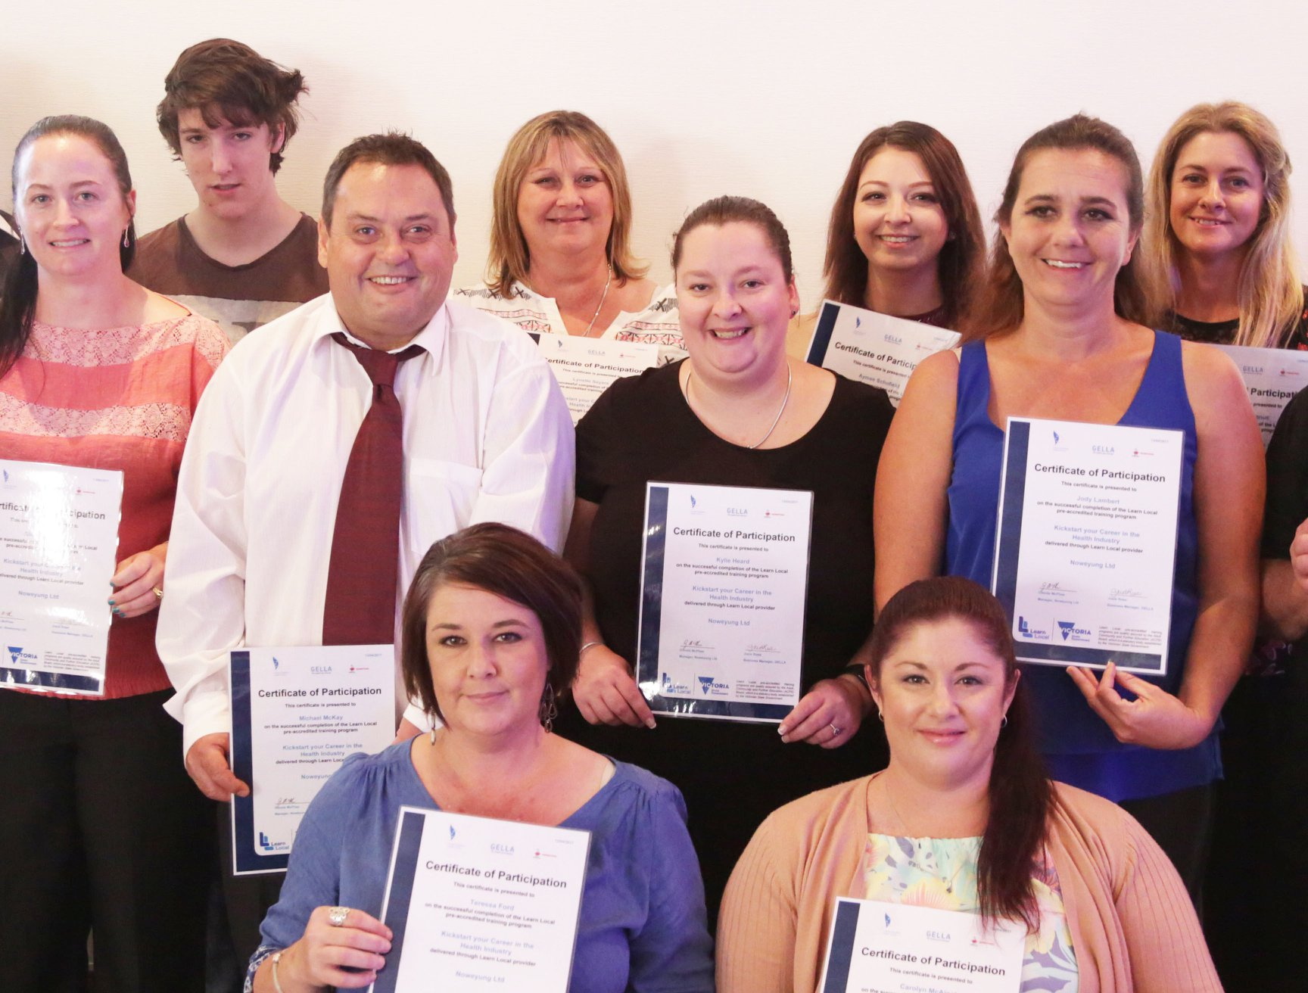

RESOURCES
PRE-ACCREDITED QUALITY FRAMEWORK

These include:
- Course Plan Part 1 – Course Overview
- Sample session plans

LITERACY FOR WORK

Teacher and Learner Guides are available for Literacy for the Workplace. The Teacher Guides include learning objectives, suggested learning activities including instructions and guiding questions, estimated time frames and a copy of the Learner Guide. Targeted employability skills are identified for each learning activity.

The Learner Guide follows lesson plans and includes written instructions for learning activities and guiding questions for discussions with provision for note taking. It also includes examples of workplace forms, a Logbook for work experience and links to online videos and websites that may be used in the classroom and/or reviewed at home prior to or after class. The Learner Guide is intended to support class-room activities and provide a record of the learning that has occurred throughout the course.

DIGITAL LITERACY FOR WORK

Resources used to develop digital literacy skills include Intel® Learn Easy Steps, tutorials from GCF Global https://edu.gcfglobal.org/en/ which can be completed online or printed and SEV Connect Moodle which contains a number of resources which can be completed in a blended format.

Learners present with a diversity of digital skills. Opportunities to practice are embedded in the course and the buddy system has proved effective in supporting those with fewer skills. A range of activities is useful to further develop the skills of more advanced learners.

FINANCIAL LITERACY

Financial Literacy is based on the five modules of ASICs Be Money Smart program available online at https://www.moneysmart.gov.au/teaching/teaching-resources These resources include online videos and workbooks.

SEV CONNECT MOODLE
This course is available in SEV Connect Moodle on https://gippslandlearnlocal.trainingvc.com.au/
Contact Buchan Neighbourhood House for access.

RECOGNITION
This course was the winner of the Shared Local Solutions Category of the 2018 Victorian Learn Local Awards.

MORE INFORMATION
This course is currently being delivered by Heyfield Resource Centre in Wellington Shire, as well as Noweyung Ltd in East Gippsland. Please feel free to contact them if you would like to know more.
Glenda McPhee
NOWEYUNG LTD.
TELEPHONE / FAX 03 5152 4605
EMAIL: gmcphee@noweyung.org.au
WEBSITE: http://www.noweyung.org.au

Caroline Trevorrow
Heyfield Community Resource Centre

TELEPHONE: (03) 5148 2100
EMAIL: coordinator@heyfield.net
WEBSITE: www.heyfieldcommunity.org.au

ACKNOWLEDGEMENT
This course was developed as part of the Strengthening Pathways for Adult Learners in Gippsland (SPALG) Project.
Appendix 1: Proposed Delivery Schedule: Kick Start your Career in the Health Sector

 | Monday  Focus: Industry Specific Skills | Tuesday  Focus: Digital Literacy for Work | Thursday  Focus: Literacy for Work | Friday  Focus: Financial Literacy
Week 1 | Introduction  Intro to the Health Sector  - Guest speaker:  - Tour of the hospital and lunch/ house keeping  - Intro to the program  - Registrations and enrolments | Computer skills for work  - Digital Literacy Assessment  - Computer basics  - Trouble Shooting  - Intro to productivity tools | Effective Communication  - Your LLN Assessment  - Effective communication  - Non- verbal communication  - Giving and receiving constructive feedback. | Saving, Budgeting & spending  - Set savings goals  - Create a budget  - Create a savings plan.  Introduction to MS Excel
Week 2 | Introduction to WHS  - Workplace policy & procedures  - Follow workplace hygiene procedures  - Manual Handling  Guest speaker: include managers from related areas | Computer skills for work  Productivity tools  - Internet and email  - Digital footprint  - Social Media Policy | Reading & writing for meaning  - Workshop position descriptions  - Language of job applications  - Writing covering letters for specific positions | Personal Tax  - Establish a system for storing receipts  - Understand how to prepare a tax return  MS Excel cont.
Week 3 | Follow basic hygiene procedures  - Hand hygiene demonstration and workshop  - Uniform policies  - Personal hygiene  - Online materials to reinforce the session.  - Cultural considerations | Computer skills for work  Productivity tools  - Word processing  - Presentation software | Resume writing  - Resume contents & layout  - Developing a resume to reflect industry requirements  - Making your resume standout | Superannuation  - Compare super funds  - Work through a super statement  - Learn to keep track of your super.  MS Excel cont.

 | Monday  Focus; Industry Specific Skills | Tuesday  Focus: Digital Literacy for Work | Thursday  Focus: Literacy for Work | Friday  Focus: Financial Literacy
Week 4 | Guest speaker  Conflict management and self-care  - Effective relationships at work  - Conflict resolution  - Stress management strategies  - Healthy living: dietetics  - Work life balance  Guest speakers: dietician and laughter yoga | Computer skills for work  Productivity tools  - Word processing  - Presentation software | Job Applications  - Applying for a position in the Health Sector  - Position descriptions within the industry  - Addressing Key Criteria  - Adapting a resume to reflect industry specific criteria | Debt Management  - Compare debt products  - Learn to manage credit cards  - Find out what to do if debt becomes a problem.  Insurance  - Investigate car, home and content insurance  - Learn how to choose the right type of insurance and level of cover.  Guest speaker
Week 5 | Work experience at BRHS | Work experience at BRHS | Getting ready for my interview  - Presentation  - Behaviour  - Communication  - Finalise resume | Mock Interviews and presentation preparation
Week 6 | Debrief Interviews & reflections on site visits  Smart Study Skills - Online | Careers in the health sector and further study options.  RTO presentations & from BRHS  Guest Speakers | Pathways planning and next steps  Careers advice  Guest speakers - Skills and Jobs centres | Celebration & Presentation

