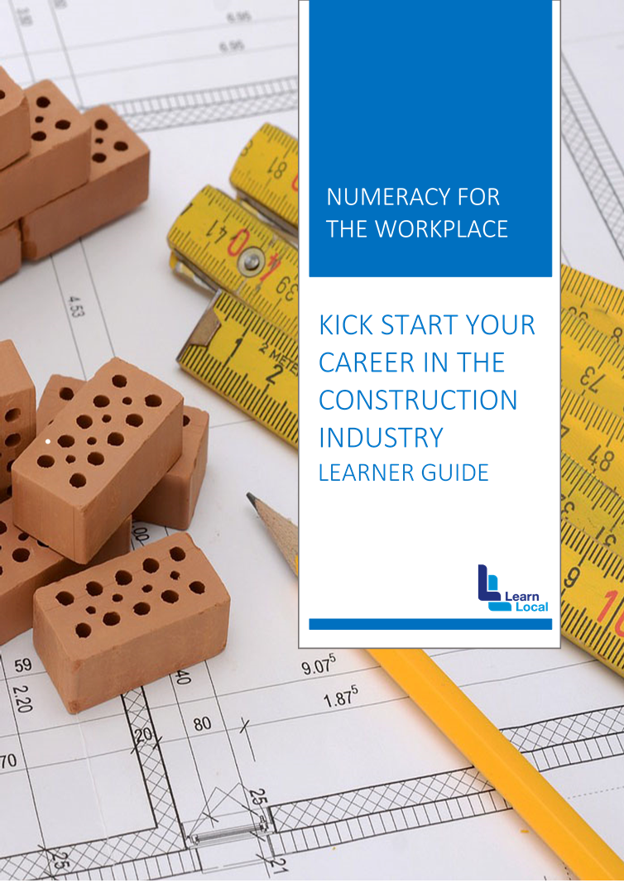

WELCOME

This learner's guide contains instructions and practice activities that will provide you with the knowledge to carry out measurements and calculations commonly used in construction work.

The topics covered include:
- taking measurements from plans
- taking physical measurements
- performing calculations
- calculating and estimating material quantities.

WHAT YOU NEED TO BRING TO CLASS

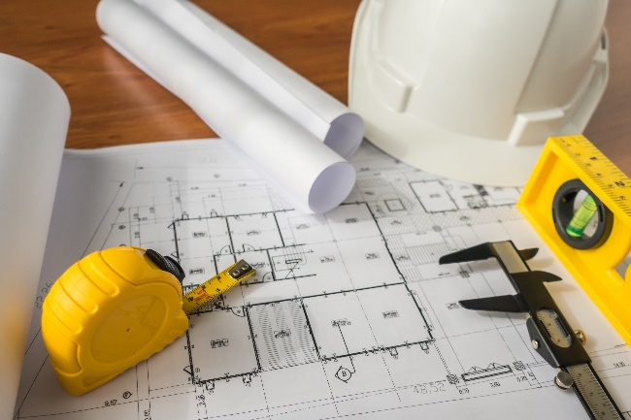
- an A4 notepad
- an A4 file for notes, handouts and printed documents
- pens, pencils, eraser and highlighters

TOPIC 1: UNDERSTANDING WORK INSTRUCTIONS

In the building industry, most of the information required by the people performing any of the work related to a construction project comes from project documentation. So, it's extremely important for you to be able to read and interpret plans, drawings, details and specifications correctly.

Plans and drawings are used to communicate great amounts of technical information between the designer and builder. This technical information must be able to be communicated without any misunderstandings, which can only happen if the technical language of plans and drawings is understood by everyone who uses them.

The technical language for plans and drawings uses standardised layouts, symbols and abbreviations so that things look similar in any plan or drawing. With study, practice and experience, you’ll get to know and understand this language and be able to follow work instructions.

TYPES OF INFORMATION

Before you begin a work task, it's important that you review and understand relevant information so that you can apply correct processes to the planning and preparation of a work activity.

This information can come in either written or verbal form. Here are a few examples of the types of information you may need to plan and prepare for a task involving measurements and calculations.

VERBAL INFORMATION

Instructions received verbally from:
- clients
- workmates
- employers
- supervisors, builders, contractors and subcontractors
- architects.

WRITTEN INFORMATION

Written instructions such as:
- plans, drawings and specifications
- manufacturers’ instructions and specifications on plant, tools, equipment and materials
- maps on job location
- safety data sheets (SDSs)
- job safety analyses (JSAs)
- legislative requirements:
  - WHS/OHS Act
  - Regulations
- Australian Standards® on work practices and processes
- safe working procedures:
  - manual handling
  - noise
  - chemicals
- signs.

TYPES OF PLANS AND DRAWINGS

There are many types of plans and drawings that may be created for a building project.
The size and complexity of the project will determine which ones are required.
The minimum set usually includes:
- a site plan
- a floorplan
- elevations
- sections.

Others that may be required, depending on the project, include:
- details
- electrical plans
- hydraulic plans
- engineering plans.

USERS AND USES
When plans and drawings of a proposed building or structure have been prepared,
many copies are made for the people who will use them.
The table on the next page shows who might use them and for what purpose.

User | Use plans to:
Owner/client | see that the design is as they imagined it
Structural, electrical and mechanical engineers | design their part of the structure
Council health and building surveyors | make sure that the building conforms to  council planning and regulations
Council town planning officers | make sure that the building conforms to building codes
Financial institution officers | Decide whether approval for finance for construction can be given
Builder/estimator | Cost the building and prepare a qoute
Builder | construct the building
Subcontractors such as concreters, bricklayers, electricians, tilers and painters | prepare their quotes to carry out their part of the construction
Suppliers of prefabricated building components such as roof trusses, windows, air conditioning and heating | calculate their prices for their part of the job.

FINDING INFORMATION

Check your knowledge about finding information on plans and drawings.

Activity 1.1 Information on plans and drawings
In the table below, four types of plans or drawings are listed across the top and 11 items of information that can be found on them are listed down the left-hand side.

For each piece of information, decide which plan or drawing it's shown on and place a tick in the corresponding box.

Some information appears on more than one plan or drawing, so you may need two ticks for those.

The first one has been done for you as an example.

 | Site plan | Floor plan | Elevation | Electrical plan
Width of paths
Overall width of building
Height of windows
Location of ceiling fans
Location of sink cupboard
Existing trees
Width of windows
Pitch (slope) of roof
Width of front door
Location of WC
Location of light switches

MEASUREMENTS

Plans and drawings show things that are to be constructed, such as foundations, walls and fences. They also show what's already on or near the site, such as trees, services and neighbouring buildings.
As well as these tangible items (things we can actually see or touch), plans and drawings also show lots of other important information, including levels, gradients, heights and measurements.

LEVELS

Levels are a very important part of construction. When the first drawings are done for a project, a ‘datum’ is established. The datum is a point that is chosen by the surveyor, assigned a number in metres and then used as the baseline or starting point for all the height measurements, or levels, on the project.

The surveyor chooses a point close to the site to locate the datum, often in the road or on the kerb, and marks it using a nail or a small metal plate. The surveyor then marks the datum on the site plan and gives it a number value, usually 10.00 or 100.00. The number itself doesn’t mean anything; it just provides a point for all other heights or levels on site to be measured against.

For example, if the datum is given the value of 10.00, then a point that is 1000 mm, or one metre, higher than the datum would be given a level of 11.00 on the site plan. A point that is 2500 mm higher than the datum would be given a level of 12.50, as shown here.

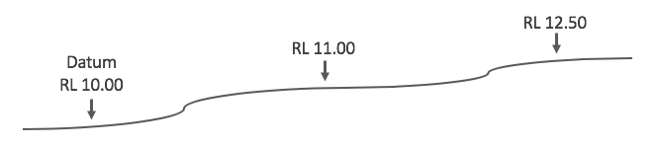
Section through ground showing relative levels (RLs) at three points.

The datum can, if necessary, be related to the nearest public datum or permanent benchmark, such as the Australian Height Datum (AHD). The AHD is a geodetic datum for altitude measurement in Australia. It allows the heights of places or points that are not within sight of each other to be compared.

Can you think of an example of a project that might need to use the Australian Height Datum?

LEVEL LINE
A level line is a line that is at a constant height relative to mean sea level (it is therefore a curved line because the earth is curved).

LEVEL DATUM
A level datum is a reference level to which the elevation of other points may be referred. In Australia, the AHD is the commonly adopted reference level. A level datum may also be assigned an arbitrary value.

BENCHMARK
A benchmark (BM) is a fixed point of reference that has a known elevation above (or below) a particular datum.

GRADIENT

The gradient (also called slope, incline, pitch or rise) of a physical feature refers to the amount of inclination of that surface to the horizontal. It's used in measuring existing physical features (such as hillsides and riverbanks), and in designing and engineering new elements for construction (such as roads, landscaping and roofing).

CONTOUR LINES
These are imaginary level lines that indicate the shape of the land (you might have seen these on maps).

Everything that is done on a construction project relies on accurate heights and levels being used. A lot of this information is found on the site plan.

Find the following items on the home plan provided.
Write the required information next to each one.

Activity 1.2 Finding information on a site plan
Find the following items on the home plan handout. Write the required information next to each one.

1. The address of the site
2. The height of the four corner pegs
3. The datum level
4. The location of the meter box
5. The length of the northern boundary

WHICH UNITS ARE USED?

The metric system is used in Australia. Some other countries use the imperial system (measuring length in feet and inches, for example). Always use the metric system when reading, measuring or calculating quantities for building projects in Australia.
The most commonly used unit of measurement in the construction industry is millimetres (mm). Lengths, widths, depths and heights are usually given in millimetres. Where larger dimensions are shown, such as the length of boundaries on a site plan, metres (m) will be used. Centimetres are very rarely used.

Often the unit itself is not written. For example, everyone just knows that if 3600 is written it means millimetres, whereas if 3.600 is written it means metres.

Unit | Abbreviation | Example | Conversion
Millimetre | mm | A fence could be 1200 high. | 1 mm = 0.001 m
Centimetre | cm | Rarely used in the construction industry. | 1 cm = 10 mm  100 cm = 1 m
Metre | m | A fence could be 14.60 long. | 1 m = 1000 mm

CONVERTING METRES AND MILLIMETRES

Sometimes it’s necessary to convert metres to millimetres. One metre is 1000 times longer than one millimetre, so you just need to remove the decimal point and make sure there are three figures after the metre amount.

For example:
2.657 m becomes 2657 mm
4.32 m becomes 4320 mm.

To convert millimetres to metres, move the decimal point three places to the left to make the number read as one thousand times smaller.

For example:
2460 mm becomes 2.46 m
12795 mm becomes 12.795 m.

If the number of millimetres is less than 1000, put a zero before the decimal point.

For example:
795 mm becomes 0.795 m.

If the number of millimetres is less than three figures, add zeroes to the left end and then place the decimal point.

For example:
65 mm becomes 0.065 m
8 mm becomes 0.008 m.

Activity 1.3 Conversions
Convert the following measurements to millimetres. An example has been done for you.
0.756 metres | 756 mm
1.46 m
21.05 m
14.749 metres
5.008 m

Convert the following measurements to metres. An example has been done for you.
649 millimetres | 0.649 m
1840 millimetres
4550 mm
12001 mm
124 mm

Activity 1.4 Interpreting a site plan
These questions relate to the site plan you received. Study the plan, and then choose the correct answer for each of the nine multiple-choice questions below.

1. The width of the building (excluding the garage) is:
- 11.79 | - 13.55
- 17.49 | - 13.612.
2. The wavy line that runs across the block (with 28.5 written at one end) is:
- a contour line | - 13.55
- 17.49 | - 13.612.
3. The ‘FFL’ under ‘Proposed Residence’ is:
- flush floor level | - 28.60 AHD
- 28.6 m | - 28.50 AHD.
4. The front elevation of the house faces:
- west | - east
- south west | - south east.
5. The setback of the house from the front boundary is:
- 6.795 mm | - 6.00 m
- 1.00 mm | - 2.80 m
6. The address of the site is:
- Lot 259 Caladenia Way | - Lot 92 Bitter Way Beechboro
- Hopscotch Homes | - not shown.
7. The distance from the rear of the house to the back boundary is:
- 29.21 m | - 5.255 m
- not shown | - 6.968 m.
8. The distance from the side of the house to the southern boundary is:
- 1.50 m | - 1500 m
- 1.00 m | - not shown.
9. The existing ground level of the block is:
- dead level | - unable to determine
- sloped down towards the top right- hand corner | - sloped down from the rear of the block to the front

